Haven Brand Guide
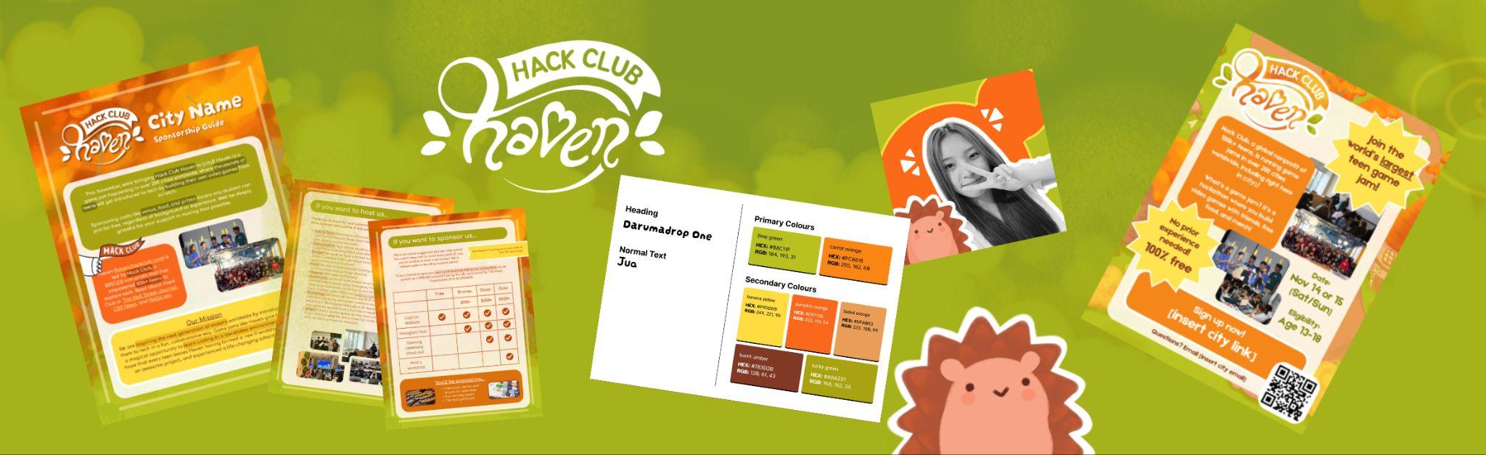
You’ll find everything Haven branding/merch related here! Most of the assets in this guide are also in this folder for you to download.

Before you create a Haven social media account, please make sure to read the Haven social media guidelines

Have a question or want to contribute a design? DM @katsu on slack <3

Use the table of contents below to navigate! (Everything is linked)

Haven Brand Guide 1
Social Media Guidelines 2
TEMPLATES 3
Flyer Template 3
Prospectus Template 4
Profile Pictures 5
BRANDING 6
Fonts + Colors 6
Logo 7
Daven Pudding 8
Site Assets 9
Background Images 10
MERCH 11

Social Media Guidelines
- Account names should be formatted as haven.[city].hackclub Ex: "haven.burlington.hackclub"
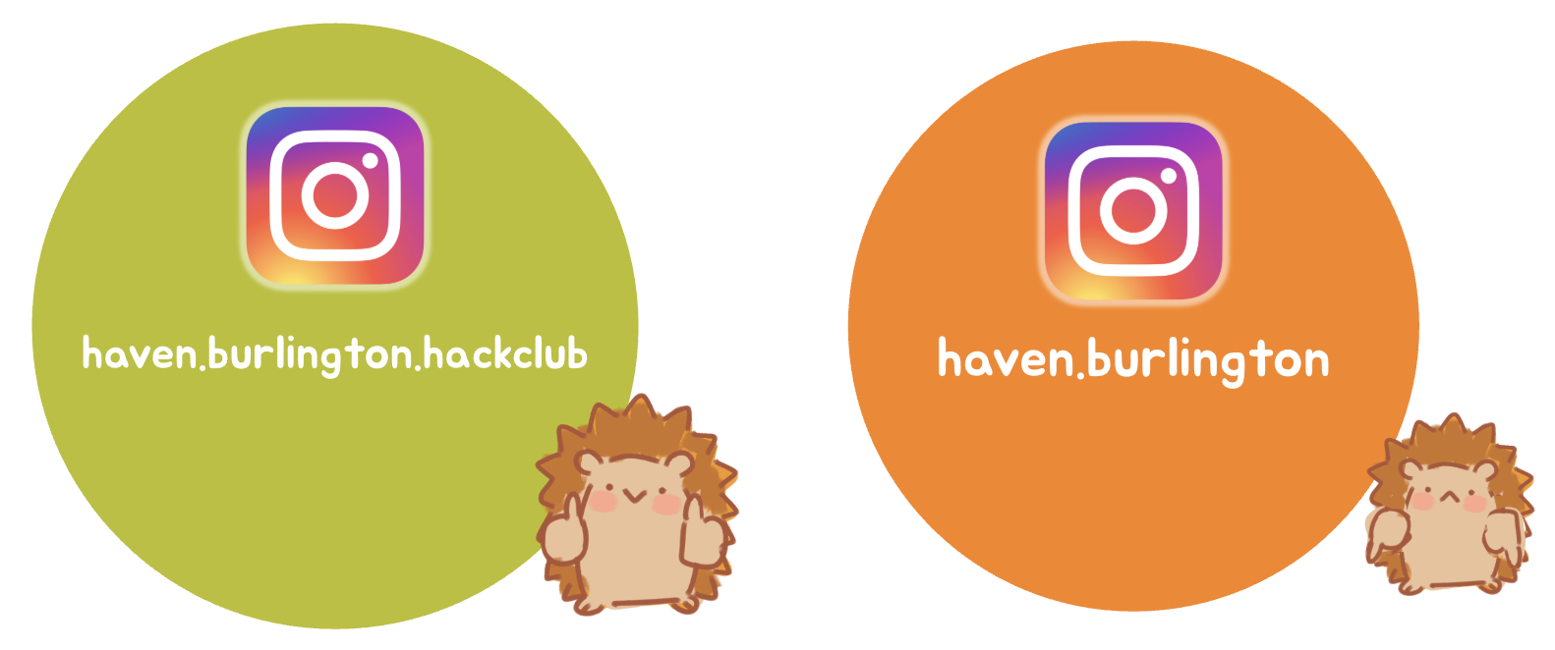
- No AI generated images. AI assisted video editing is fine in moderation, just make sure it does not scream AI
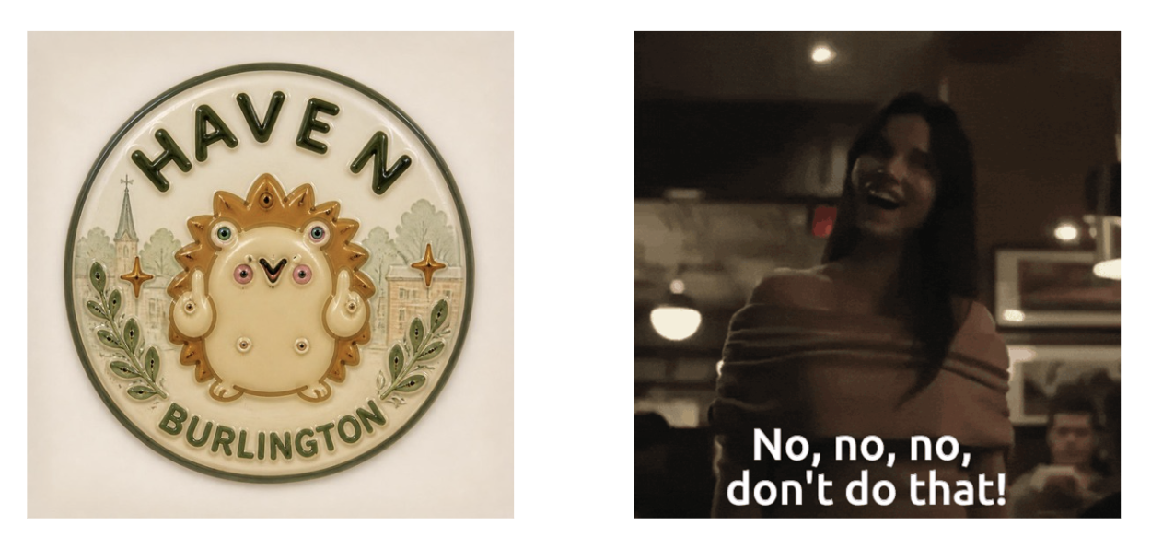
- All logos must have the mark "Hack Club" as a distinctive feature
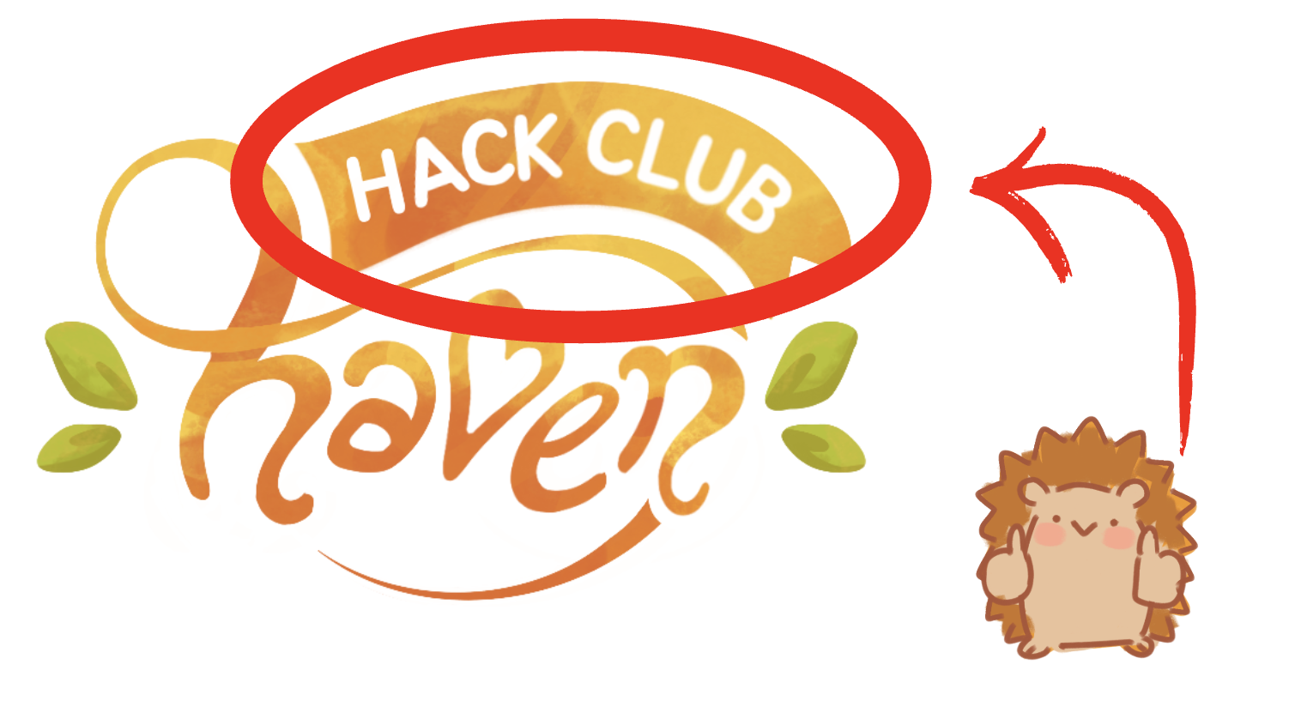
- No claiming of regions. Ex: you cannot make "hackclub.india" or "hackclub.indonesia". You can claim your high school if you're an approved Hack Club, so "eshs.hackclub" is fine.
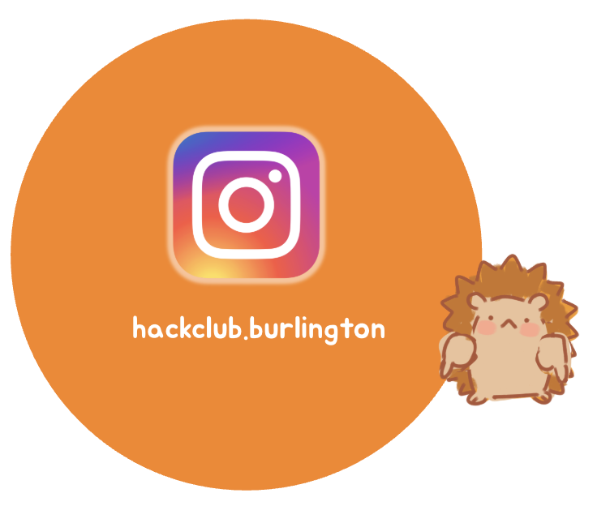

TEMPLATES

Flyer Template
Hanging up flyers around your school and community (ex: libraries) is a great way to get more sign ups!

Here is a template you can use: https://canva.link/4q0yd2z9lz4atqf
Make a copy and update these 5 things:
- Add your city where it says “including right here in [city]!” in the large text block
- Update your date
- Add your city site link
- Add a QR code to your city site
- Add your city email
If you forget to update something that will be pretty sad and aura loss so please remember to do all 5!
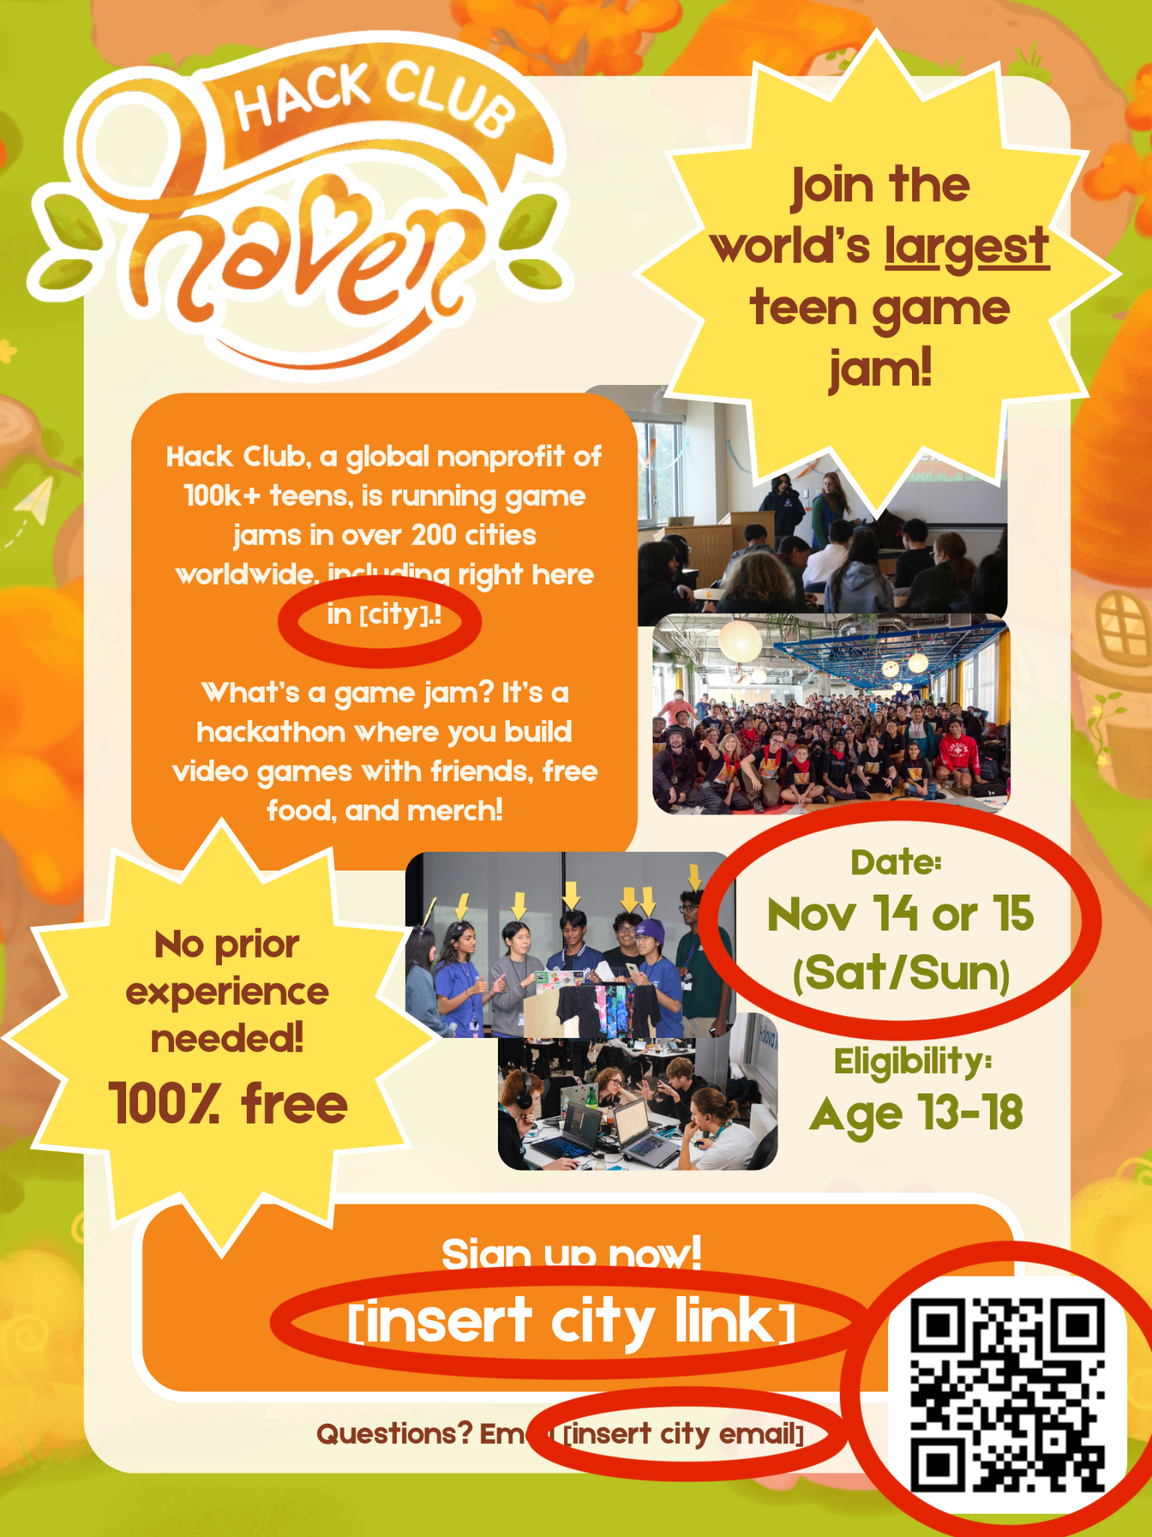
You can also check out awesome community templates here! https://app.slack.com/client/E09V59WQY1E/unified-files/doc/F0C2C8DLTJ4

Prospectus Template
You can send a prospectus to your potential sponsors (attach it at the bottom of your email). Read the entire sponsorship guide before making your prospectus.
Here is a template you can use: https://canva.link/xeueulpt0idqz6d
Make a copy and update these things:
- Page 1: “we’re bringing Hack Club Haven to [insert your city]”
- Page 2: update the entire sponsorship tier section to match your needs
- Page 2: (optional) add other costs sponsors will help cover
- Page 3: update your Haven’s date + expected attendee count
Export your finalized prospectus as a PDF! (so the links work)
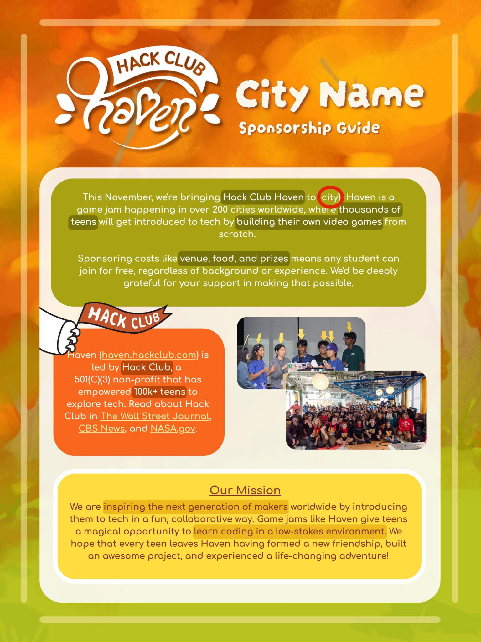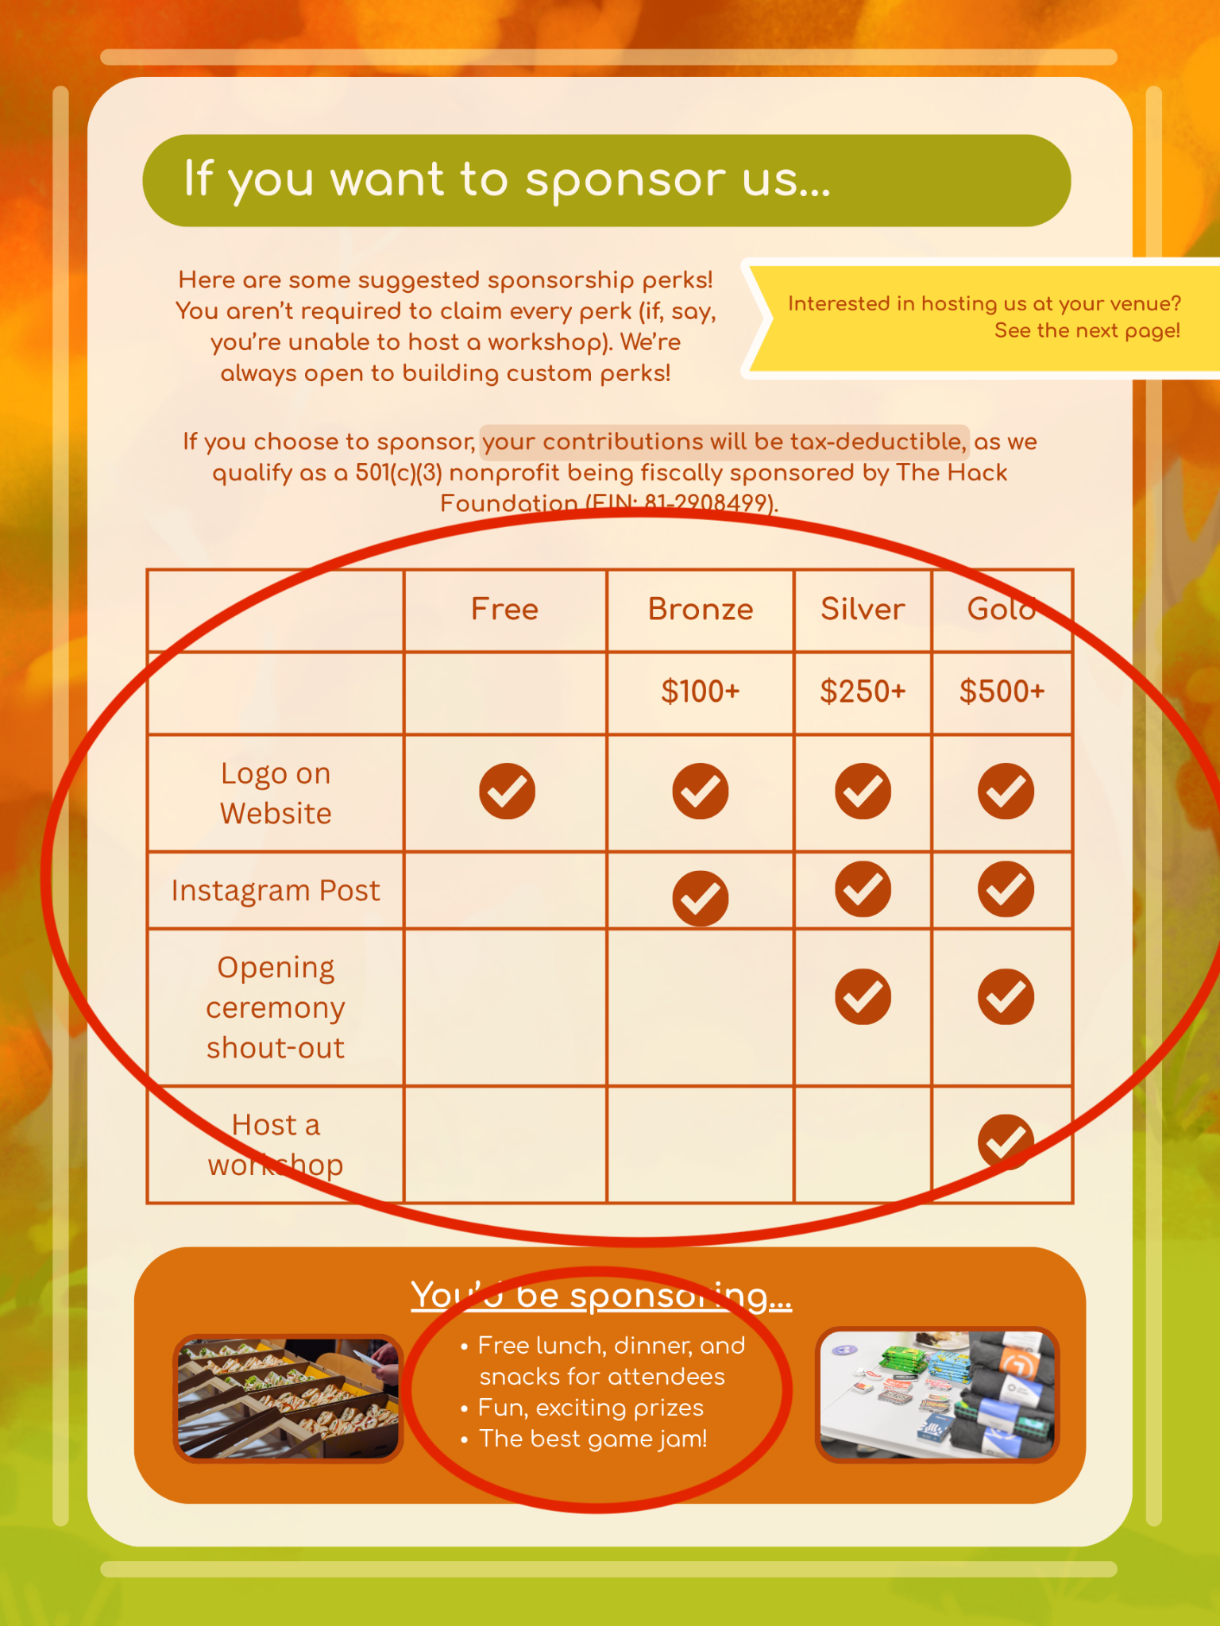
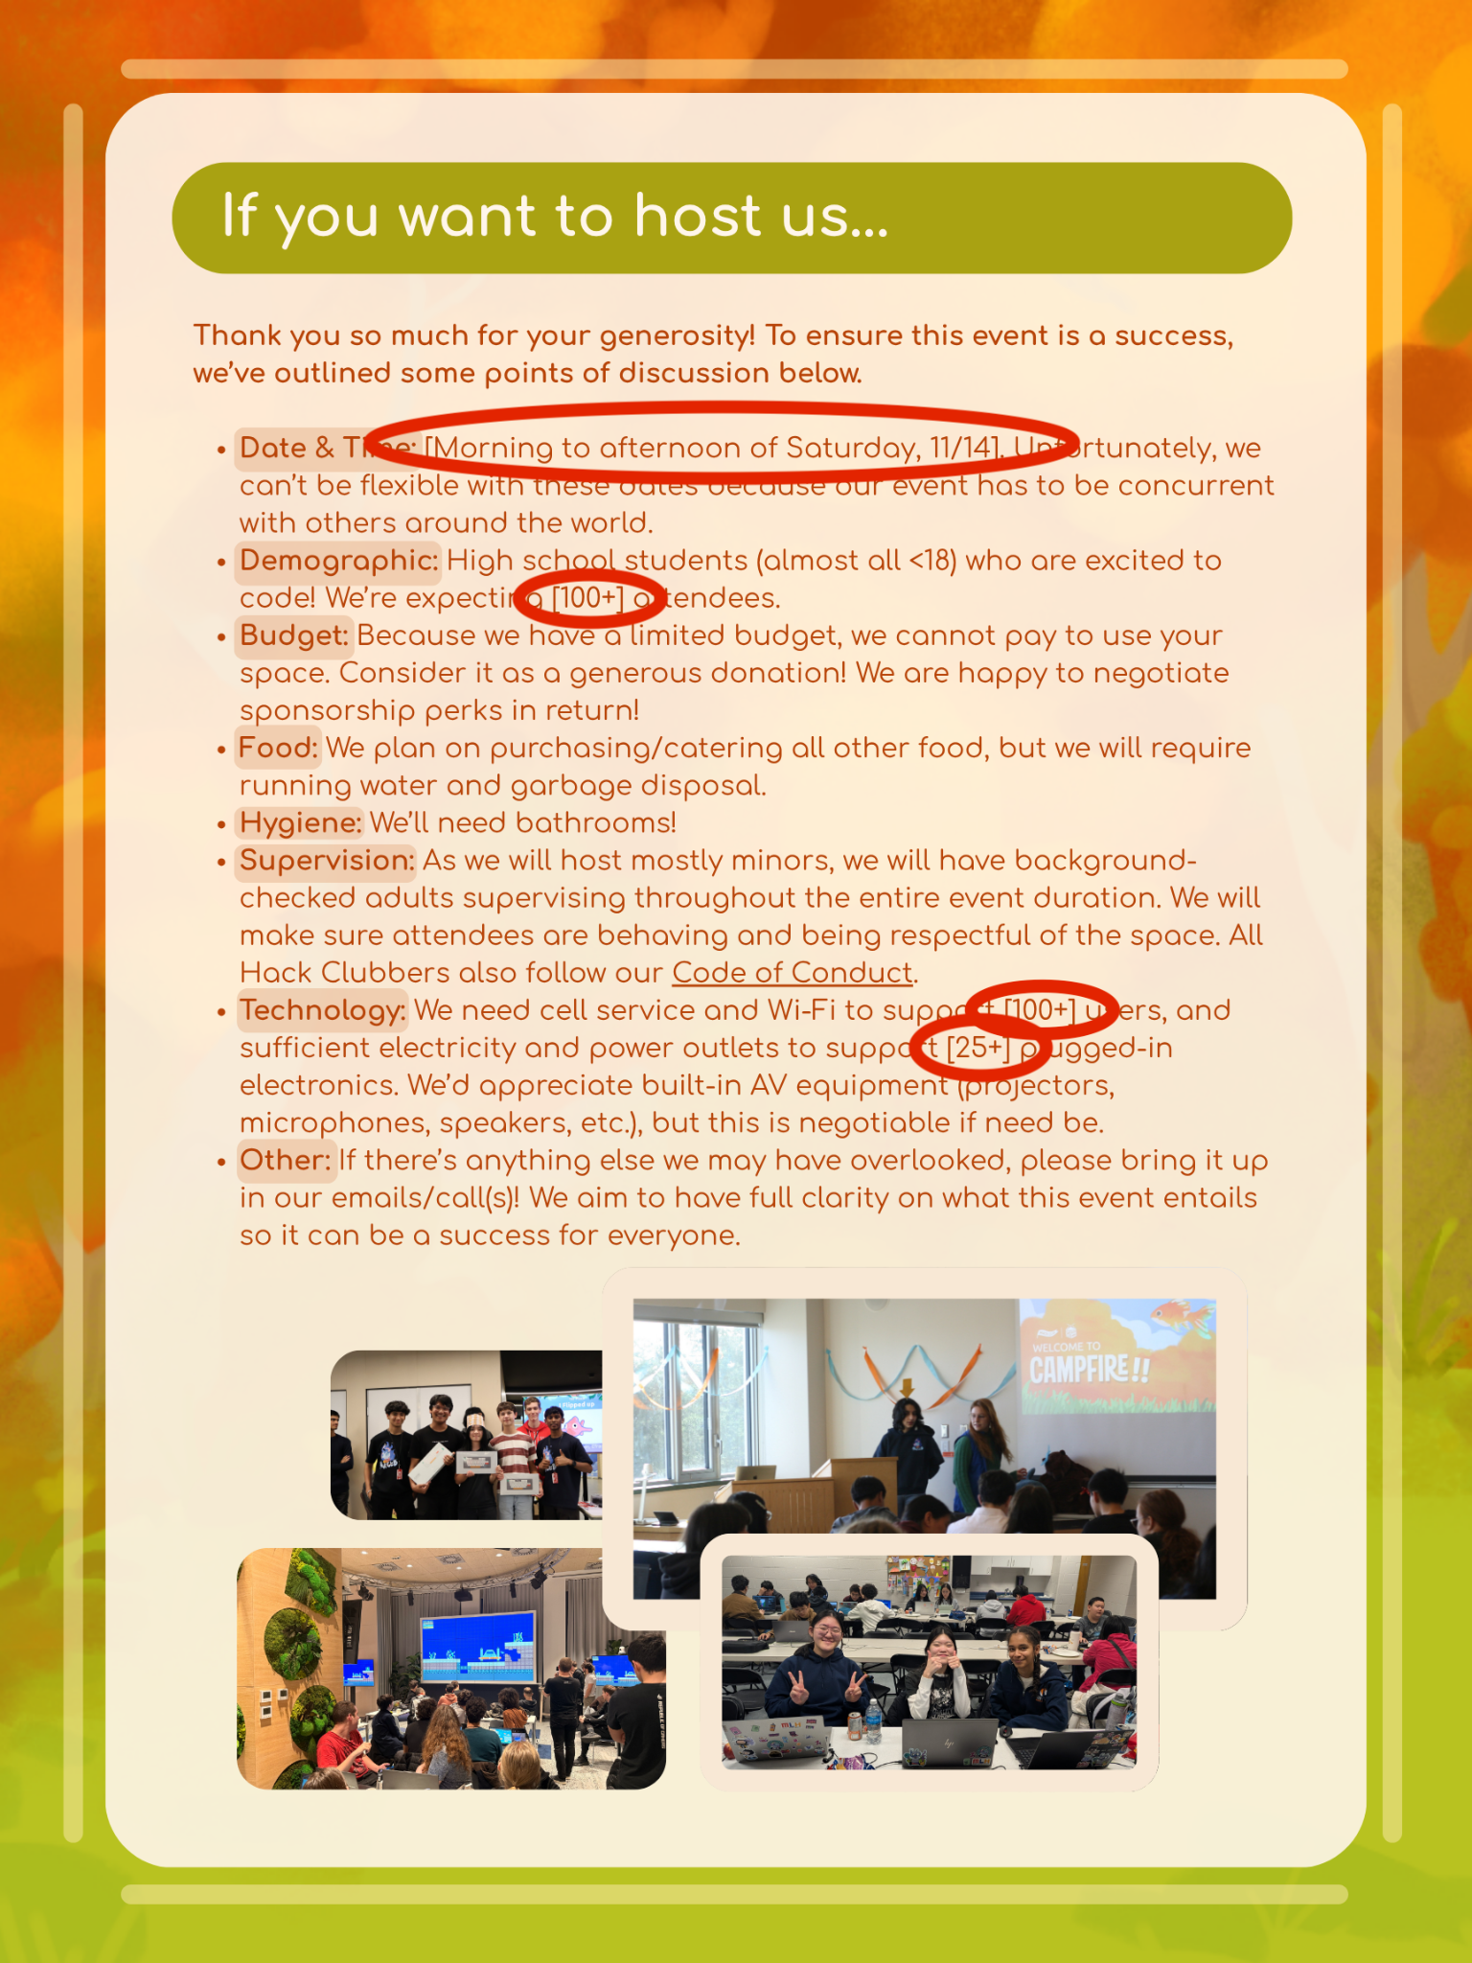

Profile Pictures
Credits: Sana <3



Want to join the super cool Haven pfp gang? Make a copy of the Canva design below and edit in a picture of yourself.

https://www.canva.com/design/DAHUtd0QudY/ZvltgjSowWlwtIuGOYXmyg/edit

You can turn the saturation all the way down to make yourself black and white. Then, add a white border around yourself!
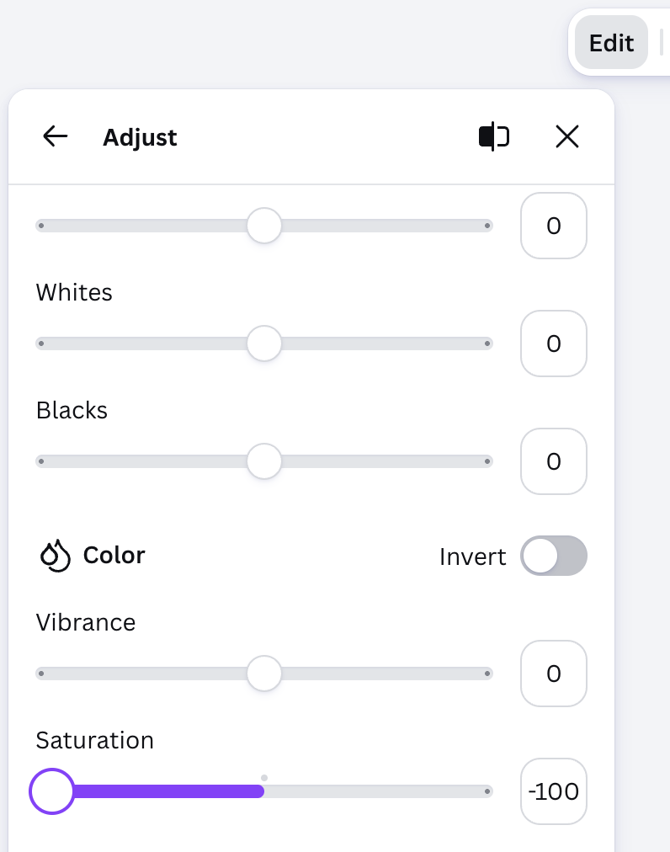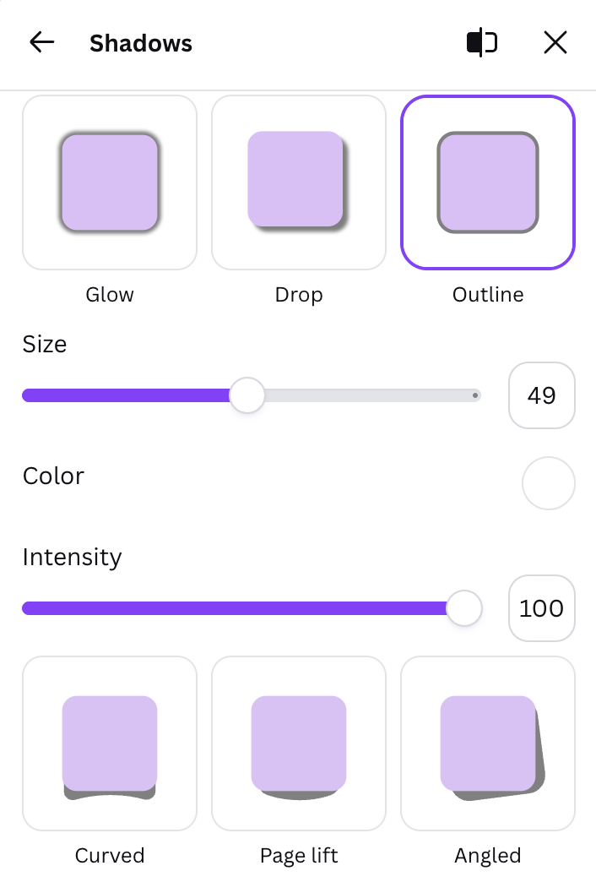

You can also just use an overlay from https://pfp.hackclub.com/c/haven!!

BRANDING

Fonts + Colors
Here are the official Haven fonts and colors! You aren’t restricted to just these colors, but focusing on them helps keep branding consistent.
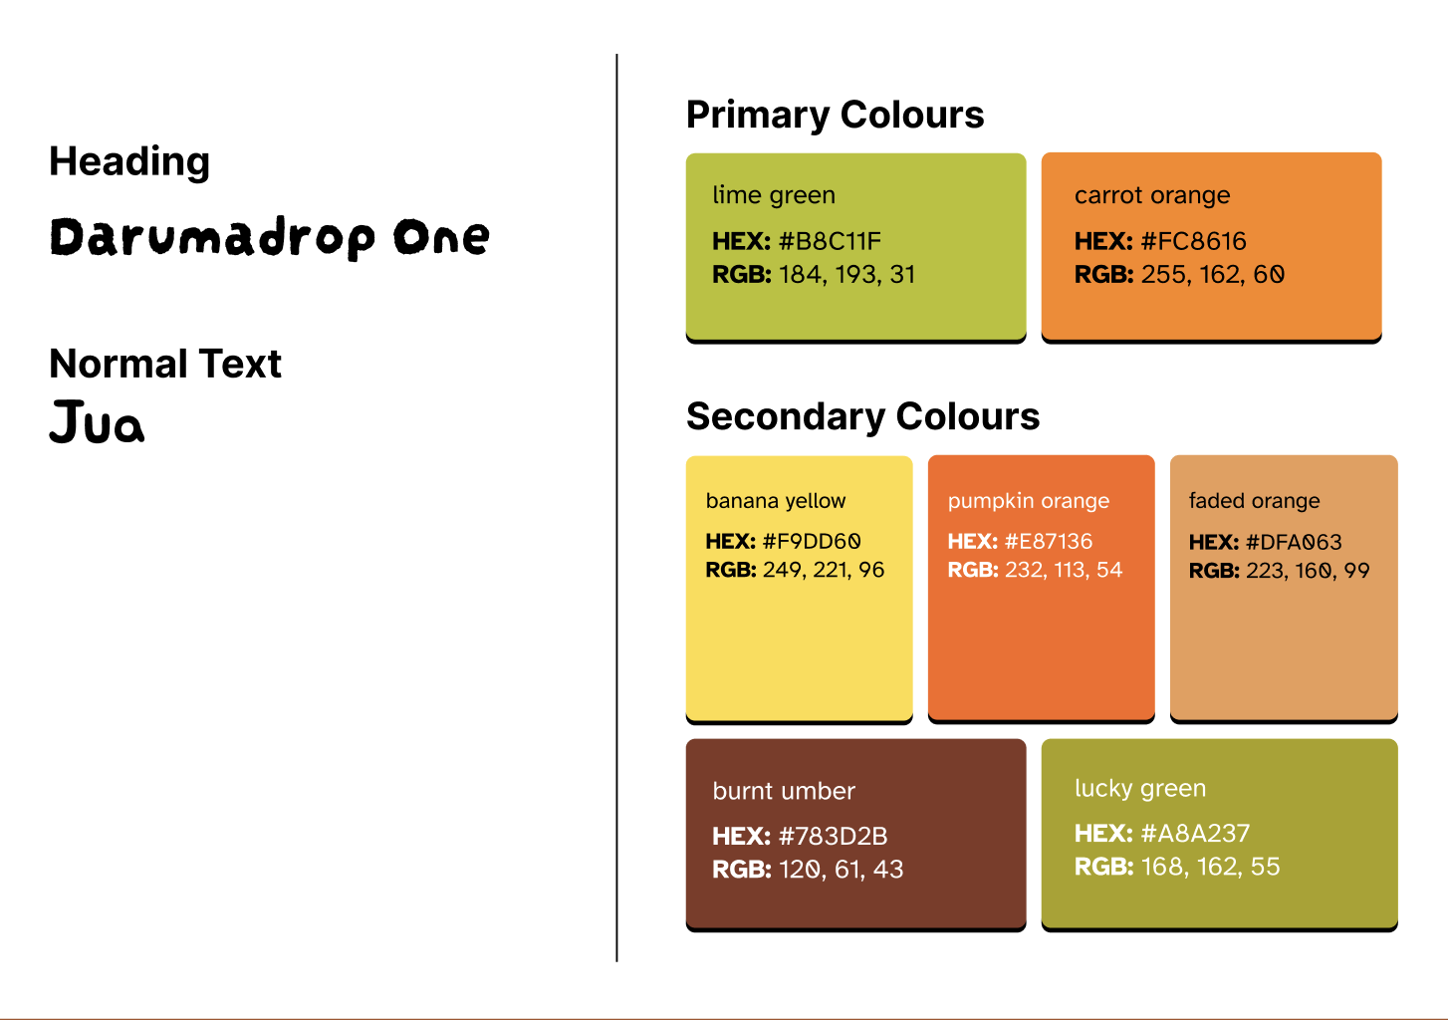
Delicious colors om nom (๑ᵔ⤙ᵔ๑)

Logo
Slap the Haven logo all over your marketing designs ✧ദ്ദി( ˶^ᗜ^˶ )

https://drive.google.com/drive/folders/1v4vESCvtETt69B3NT7nh8-TpyYbPU5X0?usp=drive_link

There are 3 logo options in the folder above:
- White
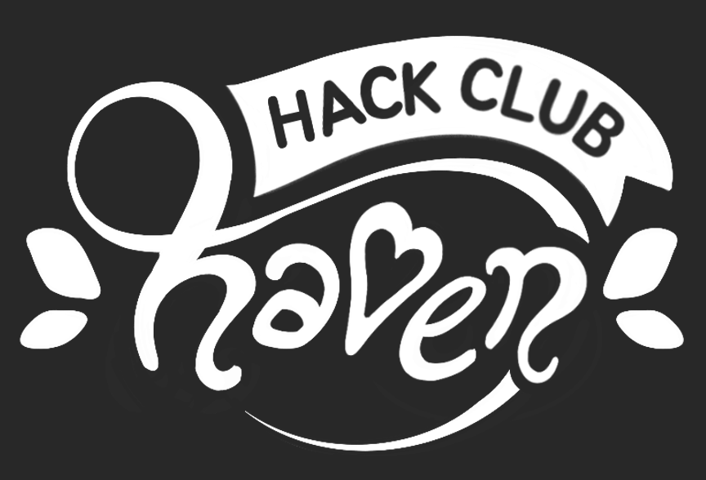
- Orange
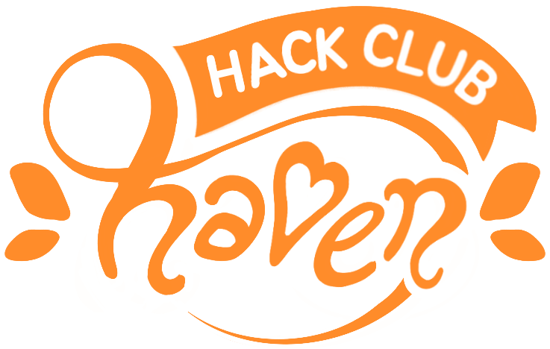
- Watercolor
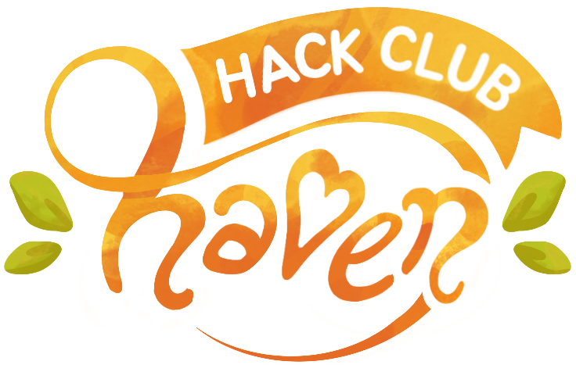

Daven Pudding 
Daven is our official mascot. He’s a spikey hedgehog, but has a soft and fuzzy personality :3

Here are some assorted daven assets you can use!

https://drive.google.com/drive/folders/1bmNQ5F2AXGuzKocF15KqJqtAwGjUtnW_?usp=drive_link



Site Assets
Want to download the image assets used in Haven’s official website? Check out this figma design!

https://www.figma.com/design/V1S8l3ju7K75ABGowht1gj/-PUBLIC--Haven-Brand-Guide?node-id=0-1&t=CNUs8iXHjgQEcAyt-1

How do you export an image from a figma design?

Select the image you want (note that most images are grouped, so you may need to open the group in the left sidebar). Then find export at the bottom of the right sidebar and click the “+” to add an export method!

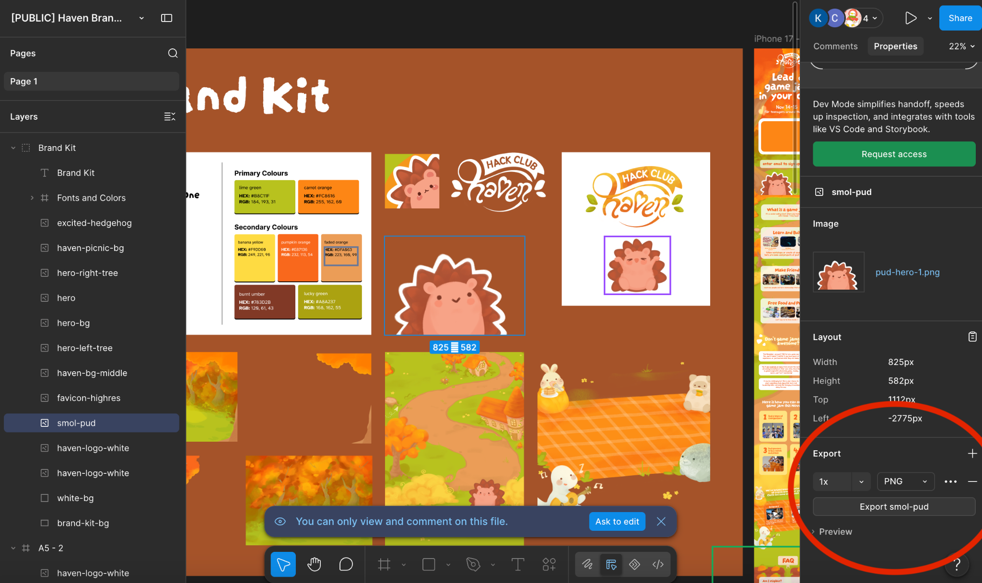

Background Images
Want to make your own promotional material? These background images might be helpful :)

https://drive.google.com/drive/folders/1f3KGEtSAkjysbSqVwkG7VuKcXOpu4pRi?usp=drive_link

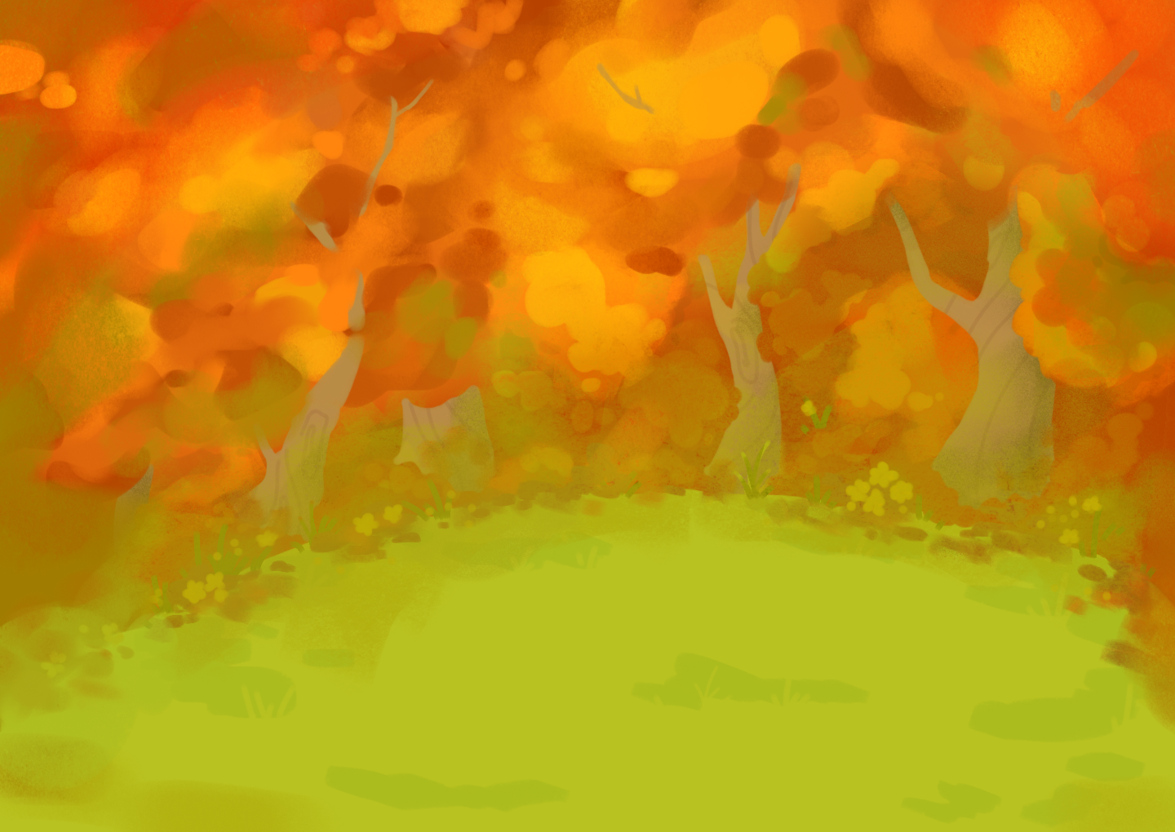

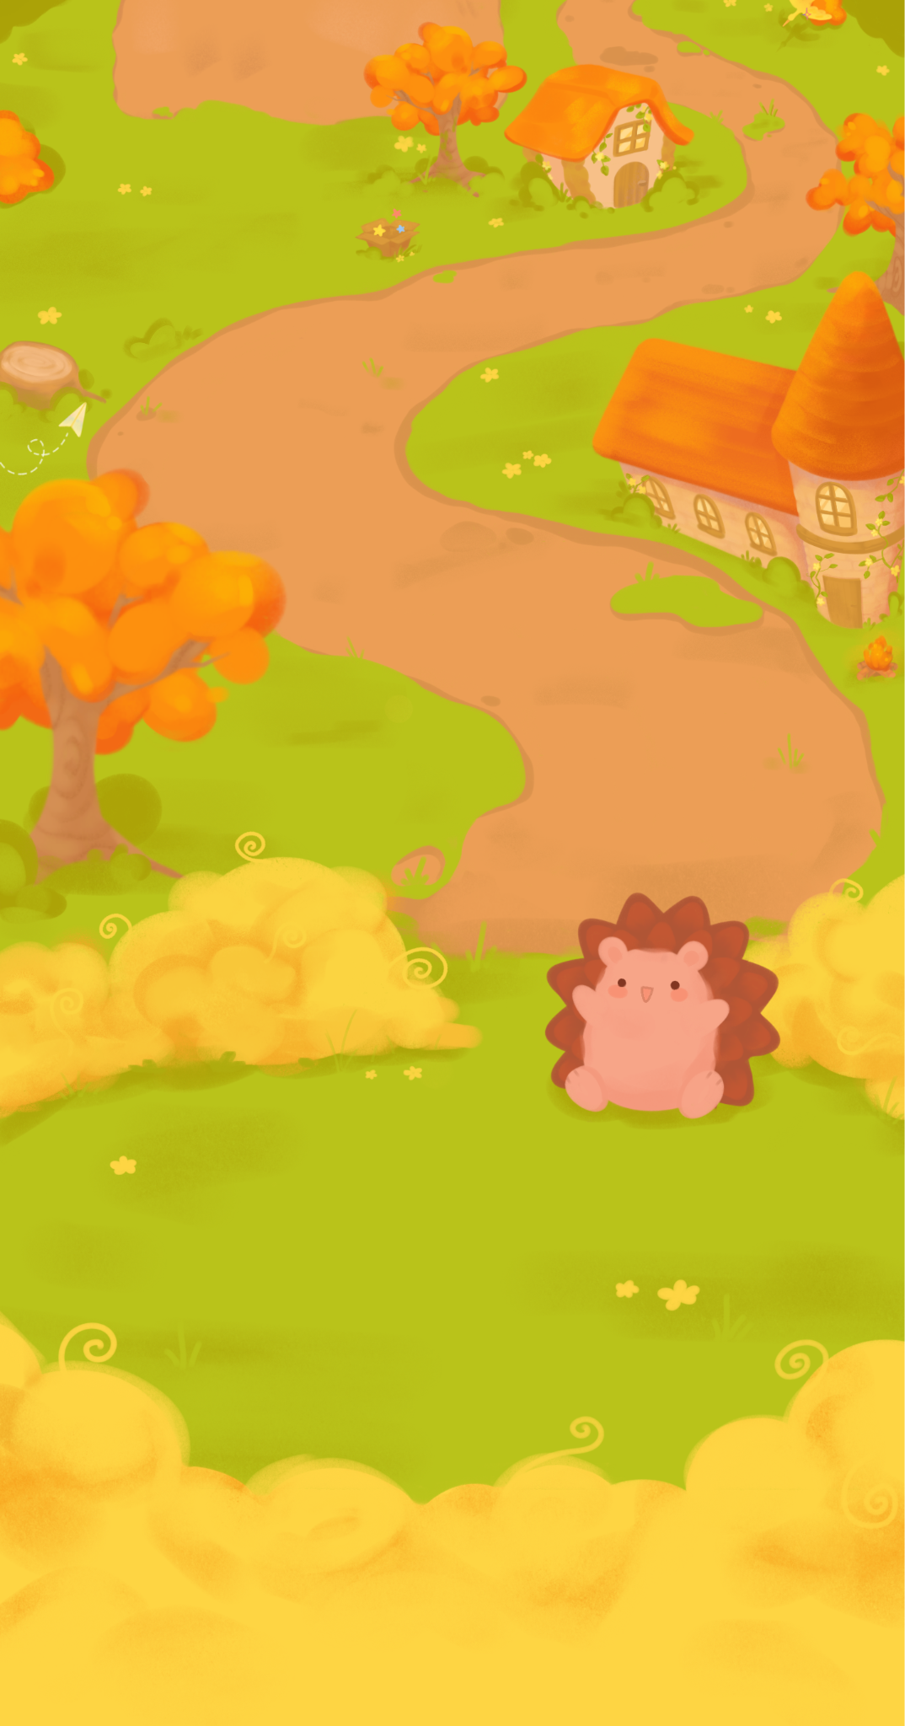

MERCH
Coming soon!

